SVTTA

OPEN 15 MILE TIME TRIAL (INCORPORATING SVTTA Speed Family Trophy) Sunday 29 September 2019.
Event HQ: Is Cambusbarron Village Hall, St. Ninians Road. Cambusbarron. STIRLING. FK7 9NU.

Parking:

There is a small car park at the centre. Some limited on-street parking on St Ninians Road and some side streets available but please park considerately.

Please DO NOT park in the housing estate behind the hall.

Sign on: Hall should be open from 08:00 hours and sign on should start shortly after this once we are set up.

Start:

The start is on the A811 approximately ½ mile to the East of the Kersebonny Road end, Cambusbarron. It is approx. 1 ½ miles from the event HQ.

The start is accessed from Cambusbarron village by turning right from the HQ entrance, proceeding into the village, turning right down Mill Brae after about a quarter of a mile and left onto Mill Road, which leads to Kersebonny Road. Turn right at the end of the Kersebonny Road (please take extra care as you will be turning over the course/traffic and riders will already be underway) and head East towards Stirling Castle. Cross the motorway flyover and the start is approx. 320 m west of Clay Toll Roundabout.
Please DO NOT warm up on the course but note that you will need to cross through the finish line to make your way to the start. If you are on the way to your start DO NOT adopt a racing position as you go through the finish area to avoid confusion for the timekeeper.

Map of route from HQ to the A811
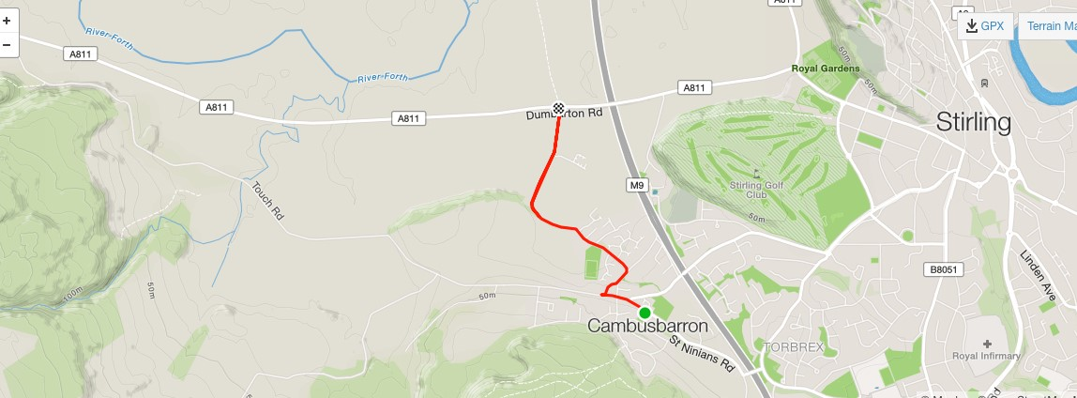
The course:

The course is an out and back along the A811. From the start it heads west to turn at the Kippen roundabout. There will be Marshals at this point. They are not allowed to stop traffic so riders must adhere to highway code when negotiating the roundabout. Retrace along the A811 crossing over the motorway flyover and finish at the entrance to Falleninch Farm. On your return to the HQ please be considerate whilst riding on A811 back to Kersebonny Road as there will be other riders who have just started their race.

Prize giving will take place back at HQ after the last riders are finished.

Start sheet for SVTTA 15 Mile TT on 29 September

Bib | Start Time | First Name | Last Name | Club
1 | 09:01:00 | Liz | Bondi | SVTTA
2 | 09:02:00 | George | Adam | SVTTA
3 | 09:03:00 | Elizabeth | Hunt | Coatbridge Clarion CC
4 | 09:04:00 | Margaret | McMillan | Deeside Thistle
5 | 09:05:00 | Russell | Mowatt | Fullarton Wheelers
6 | 09:06:00 | Jennifer | Nicol | Velo Club Vitesse
7 | 09:07:00 | Philip | Jurczyk | West Lothian Clarion
8 | 09:08:00 | Paul | Stevens | Carrick CC
9 | 09:09:00 | Jenni | Nicholson | RT23
10 | 09:10:00 | Alex | Munro | SVTTA
11 | 09:11:00 | Brian | Laffoley | Fife Century RC
12 | 09:12:00 | Andrew | Wilson | St Christophers
13 | 09:13:00
14 | 08:14:00 | I Fletcher | A MacLean | VC Glasgow South
15 | 08:15:00 | Liam | Farrell | SVTTA
16 | 09:16:00 | Carol | Middleton | Ythan CC
17 | 09:17:00 | Deidre | O’Reilly | Lanark RT
18 | 09:18:00 | Alan | Solway | Kennoway RC
19 | 09:19:00 | Dougie | Muirhead | Coatbridge Clarion CC
20 | 09:20:00 | Miriam | Rennett | Kinross CC
21 | 09:21:00 | James | Robb | Deeside Thistle
22 | 09:22:00 | David | Henderson | EH Star Cycling
23 | 09:23:00
24 | 09:24:00 | J Lumley | L Sloan | Walkers/Fullarton
25 | 09:25:00 | Jim | Prentice | Stirling Bike Club
26 | 09:26:00 | George | Skinner | Royal Albert CC
27 | 09:27:00 | Lindsay | Foster | Ayrodynamic Triathlon
28 | 09:28:00 | William | McMillan | Glasgow United
29 | 09:29:00 | Steve | Donaldson | Fullarton Wheelers
30 | 09:30:00 | Andrew | Stewart | Dunfermline CC
31 | 09:31:00 | Allan | Duncan | Fullarton Wheelers
32 | 09:32:00 | Des | Grant | Coatbridge Clarion CC
33 | 09:33:00 | Robert | Brown | EH Star Cycling
34 | 09:34:00 | Fiona | Davidson | Dundee Wheelers
35 | 09:35:00 | Steve | Wallace | Dunfermline CC
36 | 09:36:00 | Neil | McLeod | SVTTA
37 | 09:37:00 | Christina | MacKenzie | Stirling Bike Club
38 | 09:38:00 | Catherine | Logan | Fullarton Wheelers
39 | 09:39:00 | Steven | Horne | Airdrie CC
40 | 09:40:00
41 | 09:41:00 | Bill | Munro | Glasgow Wheelers
42 | 09:42:00 | Patricia | Baird | Ecosse Performance CC
43 | 09:43:00 | Fred | Connor | VC Glasgow South
44 | 09:44:00 | Val | Martin | Dooleys Cycles
45 | 09:45:00 | James | Muir | Glasgow Nightingale
46 | 09:46:00 | Charles | Adam | VC Glasgow South
47 | 09:47:00 | Allan | Ross | Fruin RC
48 | 09:48:00 | Kevin | Lackie | RT23
49 | 09:49:00 | Alex | McPhee | Dooleys Cycles
50 | 09:50:00 | Gavin | Laffoley | Fife Century RC
51 | 09:51:00 | Dave | Pritchard | Kennoway RC
52 | 09:52:00 | Michael | Giles | Ythan CC
53 | 09:53:00 | Bll | Groves | EH Star Cycling
54 | 09:54:00 | Brian | Nicol | Velo Club Vitesse
55 | 09:55:00 | Jim | Petrie | Dundee Wheelers
56 | 09:56:00 | Gary | Bratt | Fruin RC
57 | 09:57:00 | Derek | McMillan | St Christophers
58 | 09:58:00 | Ian | Elliot | Hawick Wheelers
59 | 09:59:00 | David | Ross | Falkirk Bike Club
60 | 10:00:00 | Steve | Nutley | RT23
61 | 10:01:00 | Sean | Quinn | Law Wheelers
62 | 10:02:00 | Martin | Godfrey | Glasgow Green CC
63 | 10:03:00
64 | 10:04:00 | Alan | Davidson | Dundee Thistle
65 | 10:05:00 | Brian | Muir | Royal Albert CC
66 | 10:06:00 | Stuart | MacCallum | Dundee Thistle
67 | 10:07:00 | Nicholas | Manson | Dunfermline CC
68 | 10:08:00 | Graham | Jones | Edinburgh RC
69 | 10:09:00 | Angus | Wilson | Dundee Thistle
70 | 10:10:00 | Jim | Cusick | Dooleys Cycles
71 | 10:11:00 | Neil | Pendrich | SVTTA
72 | 10:12:00
73 | 10:13:00 | Douglas | Watson | GTR – Return to Life

